Project Report

HOMELESSNESS IN THE UNITED STATES FROM 2014 TO 2017

Group Members:

Anthony

Alcina Travis

Ashee Gala

Udita Shukla

INTRODUCTION

Homelessness in America is approaching a crisis level.

According to findings across several resources, on a single night in 2017, 553,742 people were experiencing homelessness in the United States. For every 10,000 people in the country, 17 were experiencing homelessness. Approximately two thirds (65%) were staying in emergency shelters or transitional housing programs, and about one third (35%) were in unsheltered locations. Homelessness increased for the first time in seven years.

This project specifically aims to help researchers so that appropriate measures can be taken in order for the homelessness rates to decline. This project shows strong statistics about the different types of people affected due to this problem.

The data analysis done here will help researchers to effortlessly sift through the data. today’s Information Age routinely produces a tidal wave of data, enough to overwhelm even the most dedicated researcher. Data analysis, therefore, plays a key role in distilling this information into a more accurate and relevant form, making it easier for researchers to do to their job. Data analysis also provides researchers with a vast selection of different tools, such as descriptive statistics predictive analysis etc.

Data analysis is needed as such an enormous amount of data which a vast variety can tend to be overwhelming for an indivisual to understand the desired questions.

DATA

The dataset is obtained from hud. It consists of 18 Columns and 204 rows out of which all the rows are numerical.(real world data- government )

* Pre-processing:

Initially the dataset consisted of multiple missing values and required cleaning. Additionally, multiple datasets had to be clubbed together to provide a better results related to the project topic. The datasets that were additionally clubbed were the Rent, Population and the grants datasets. further the column had to be converted to snake case. The null values in the dataset were replaced with 0. The dataset originally consisted of multiple years, was then filtered only from 2014 to 2017 for this project.

* Key Variables:

Amongst the multiple columns from the dataset, the key columns were observed to be the ‘Amount Funded’ , ‘Population’ , ‘Price’.

* Descriptive statistics:

Based on the descriptive statistics done, the observations were as follows:

1. The top three states with the highest number of homeless people were to be

-California

-New York

-Florida

1. The change in the number of homeless people over the years was observed to decline significantly until 2016 after which there was a rise in the total homelessness.
2. The change in the number of sheltered homeless people over the years declined drastically from 2014 till 2017. The sheltered homeless decreased by 40,000.
3. While the unsheltered homeless increased gradually until 2016 to 17 where the number seemed to have shot up drastically by 17,000.
4. On the contrary, the amount funded increased significantly from 2015.
5. Over the years, we observed that as the unemployment rate decreased, the number of total homeless also decreased slightly but inspite of the amount funded to reduce two states consistently were shown to have increasing homelessness even after the funding.

EXPLORATORY ANALYSIS

Using Linear Regression, reliability of each variable on the dataset has been shown.

1. What is the relationship between unemployment and homelessness rate

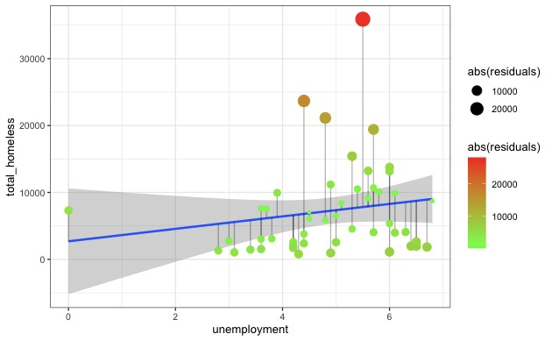

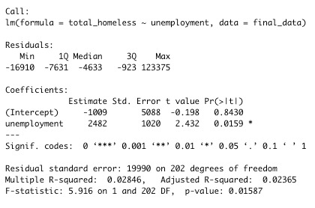

1. What is the relationship between rent price and homelessness rate

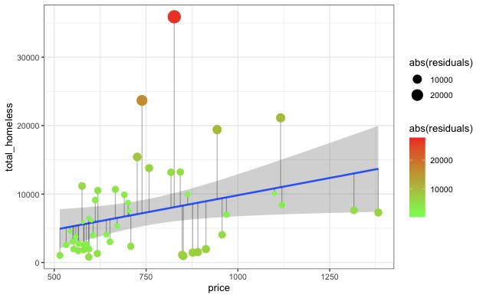

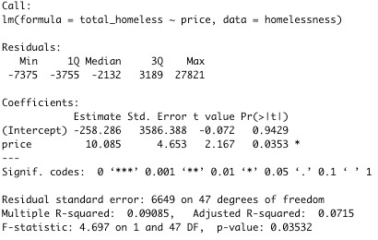

1. What is the relationship between Population and homelessness rate

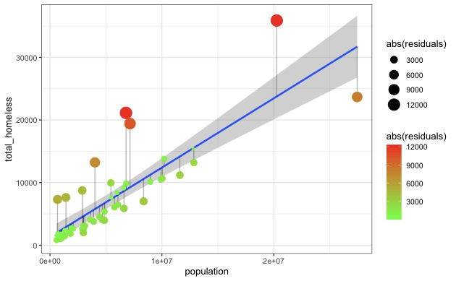

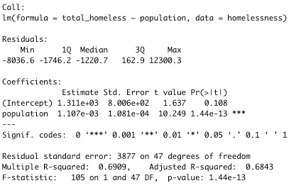

1. What is the relationship between Amo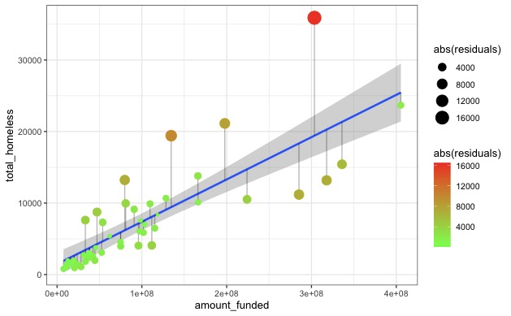unt funded rate and homelessness rate

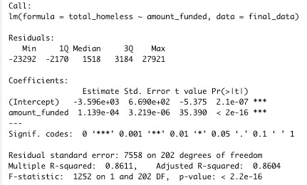

RESULTS AND CONCLUSION

REFERENCES:

1. <https://www.hudexchange.info/homelessness-assistance/ahar/#2017-reports>
2. <https://github.com/rebeccaebarnes/Homelessness/blob/master/datasets/working/homeless-clean.csv>
3. <https://www.huduser.gov/portal/sites/default/files/pdf/2017-AHAR-Part-1.pdf>